EE4717 Web Application Design

Project Report

F33-DG

A Saravanan EE4717

M Rubern Chakravarthi EE4717

Project Title: How’s Catering Online Ordering System

Summary of Project:

The Online Ordering System is a web-based ordering system that supersedes the current phone based ordering system that is in place. Customers are able to easily view the entire menu and are able to interactively select the package and dishes that they wish to order.

Contents

Chapter 1 Application Requirements and Specifications 1

Requirement 1 - Provide a web platform for How’s Catering 1

Requirement 2 – Provide the full menu 1

Requirement 3 – Online Ordering 1

Requirement 4 – Transaction Enquiry 1

Chapter 2 Functional Requirements and Specifications 2

Requirement 1 - Provide a web platform for How’s Catering 2

Requirement 2 – Provide the full menu 2

Requirement 3 – Online Ordering 2

Requirement 4 – Transaction Enquiry 2

Chapter 3 Design of the Web Application 3

Site Map 3

Story Board 4

Home Page 4

Menu 4

Transaction Enquiry 5

Contact Us 6

Ordering 7

Wireframe 8

Appendix A - Wireframe Diagrams

# Application Requirements and Specifications

The objective of building the web application is to create a web presence for How’s Catering and setup an online catering ordering system. This system would supersede the current phone based ordering system the company has in place. The requirements for the application are listed below.

## Requirement 1 - Provide a web platform for How’s Catering

Users should able to easily identify that the website belongs to How’s Catering and understand that the company provides high quality catering services.

## Requirement 2 – Provide the full menu

Users should be able to view the full menu that How’s Catering offers easily.

## Requirement 3 – Online Ordering

Users should be able to efficiently order using the website.

## Requirement 4 – Transaction Enquiry

Users should be able to enter the transaction number provided at the end of the transaction and view the details of the orders.

# Functional Requirements and Specifications

The following paragraphs will detail how the application requirements specifications will be achieved.

## Requirement 1 - Provide a web platform for How’s Catering

The landing page of the web site will be designed such that users who view the page will be able to easily identify How’s Catering through the usage of the company logo as well as the match to the company’s color palette. A slideshow of the most popular dishes ordered by the customers as well as the company mission will be clearly shown on the page.

## Requirement 2 – Provide the full menu

The entire menu will be stored inside the SQL database. A separate page will be dedicated to showing the menu. The page would be broken down into different parts so as to reduce the time taken for each query.

## Requirement 3 – Online Ordering

How’s Catering sells its catering through different tiers of packages. The online ordering system will allow a customer to select the tier of package that he/she wishes and customize the menu within the parameters of the tier. After which the customer will be able to enter the delivery details as well as contact information. The payment portal will handle the payment. After confirmation of successful payment has been made, a transaction reference number will be provided and the information will be stored inside the database.

## Requirement 4 – Transaction Enquiry

Using the transaction reference number, the customer will be able to query for details of their orders efficiently. They will need to key in the number into the box and submit, after which an SQL query will be performed and the details of their transaction will be returned.

# Design of the Web Application

The following content show cases the design of the web application.

## Site Map

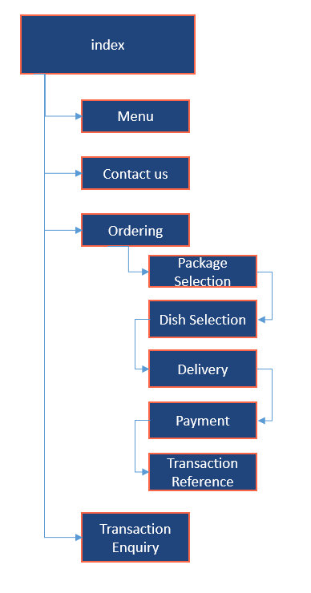

## Story Board

### Home Page

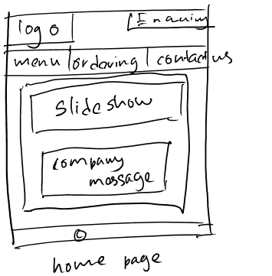

### Menu

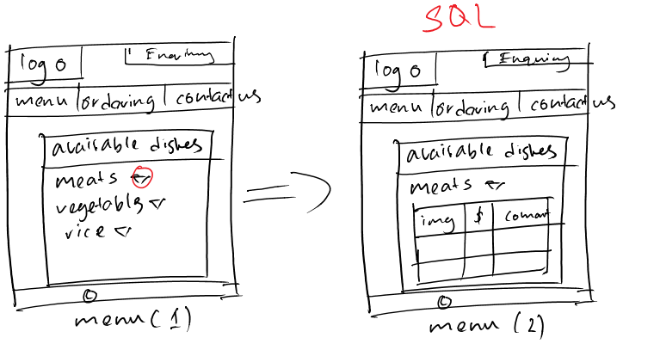

### Transaction Enquiry

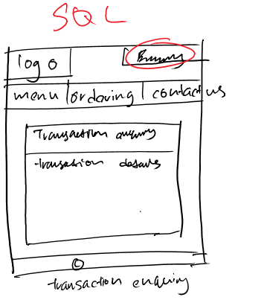

### Contact Us

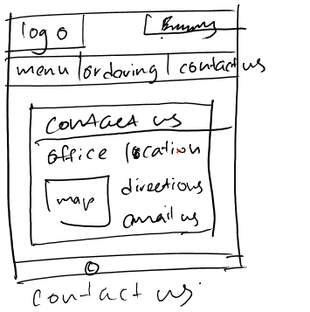

### Ordering

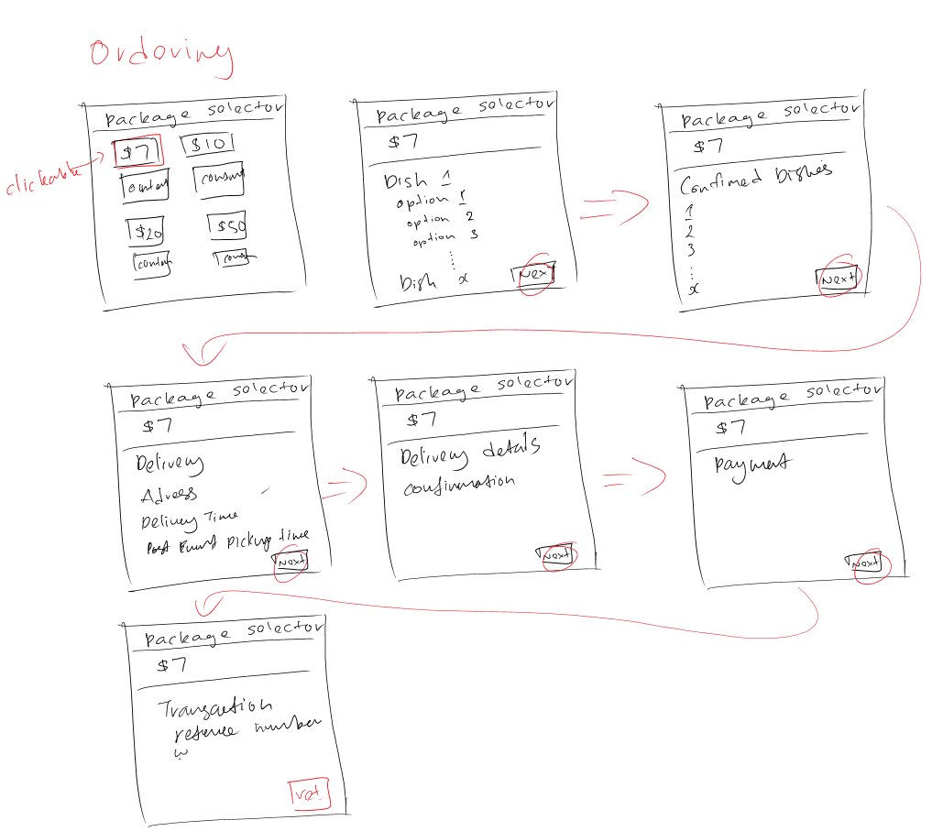

## Wireframe

Due to the size of the wireframe diagrams, they have been contained in Appendix A – Wireframe diagrams.

